Central Railway Divisional Office,
Gati Shakti Unit,
Pune -411001
No. PCDO/Pune/GSU/April-25 Date: 5th May 2025
To,
CE/SD/CR

Sub: Monthly Performance for the Month of April -2025

- Highlights:

Amrit Bharat Station Scheme–

  - Soft Upgradation/Redevelopment of Stations– In Pune division 20 stations have been identified to be redeveloped under the Amrit Bharat Station Scheme. Details of works sanctioned/in progress are as under:

No. of stations identified | No. of works sanctioned | Tender opened | Tender finalized | Work started  (Nos of Stn) | Stations completed
20 | 20 | 20 | 20 | 20 | 3

  - Major Upgradation/Redevelopment of stations–

- Highlights/Achievements on Soft Upgradation works at Amrit Stations (With pictures)

Sr. | Name of  Station | Highlights/  Achievements | Photo
1 | Satara | Waiting Hall | Date: 02.05.2025  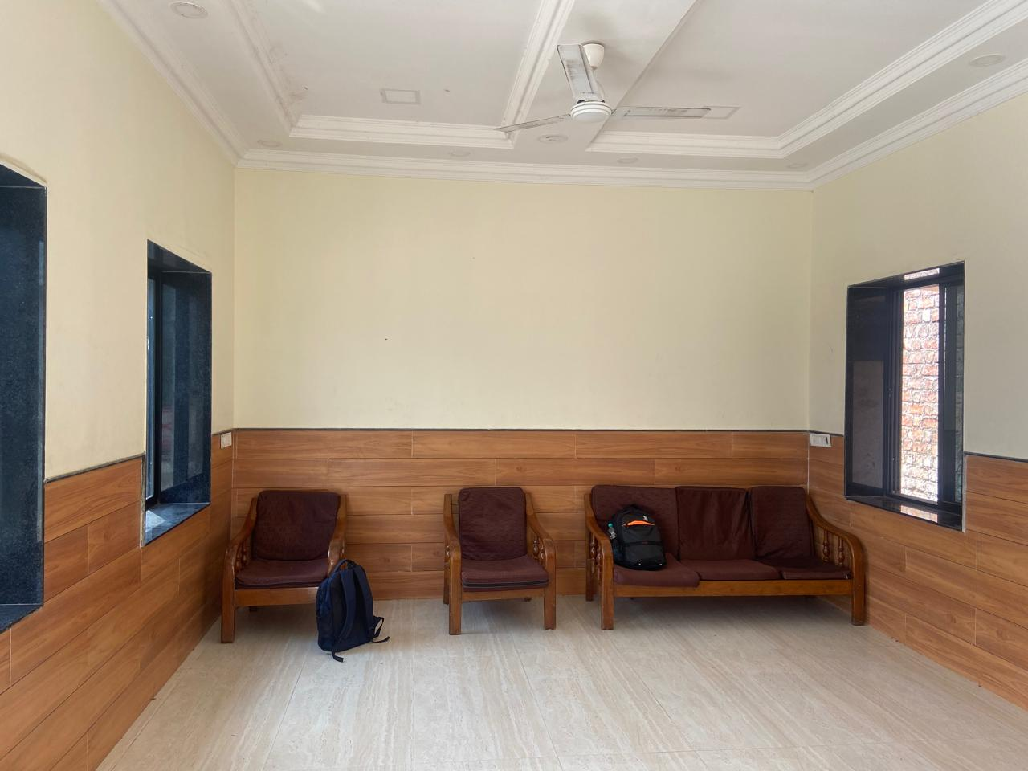
2 | Satara | Waiting Hall Attached Gents Toilet | Date: 02.05.2025  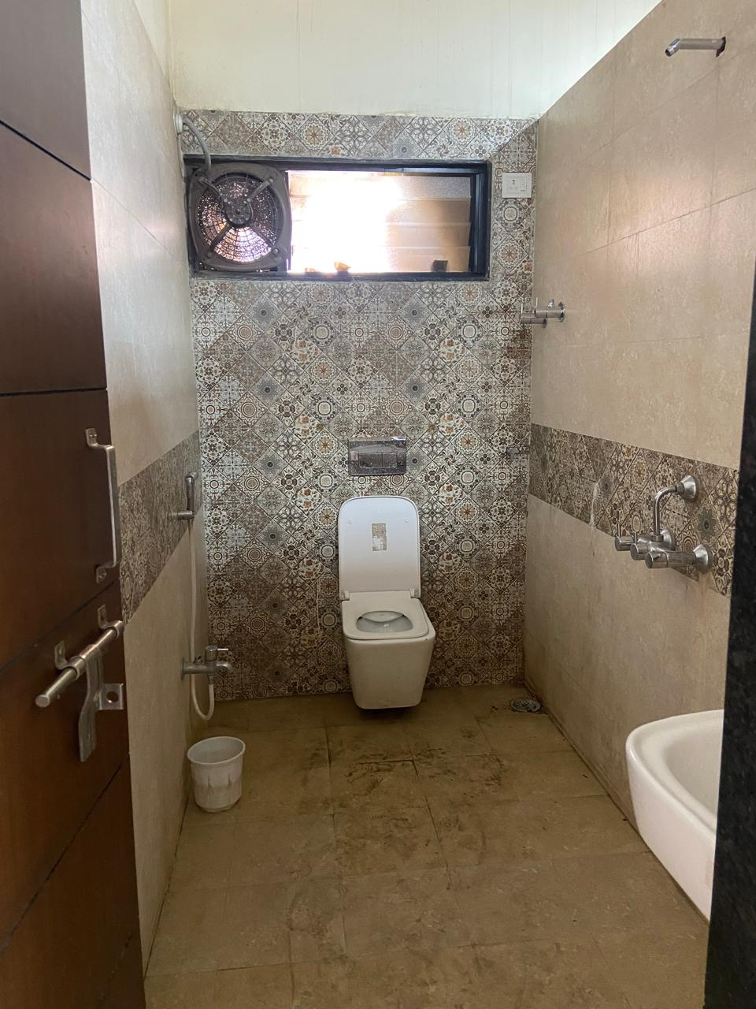
3 | Satara | Waiting Hall Attached Ladies Toilet | Date: 28.03.2025  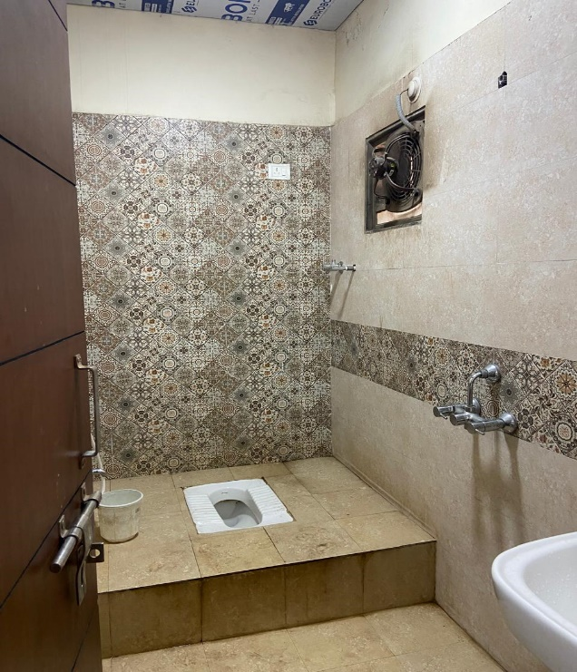
4 | Baramati | Water booth | Date: 2.5.2025  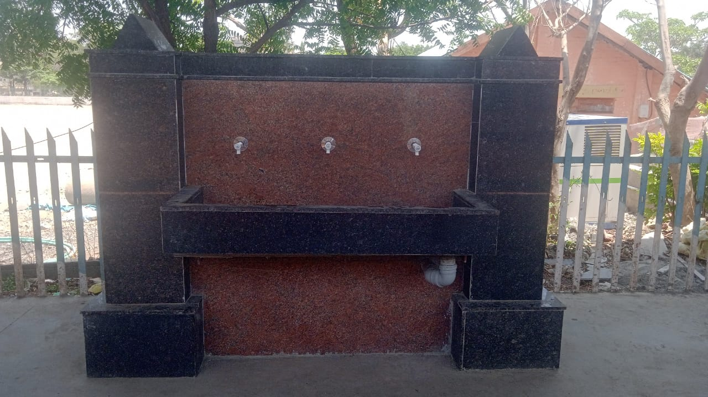
5 | Baramati | COP Completed | Date: 2.5.2025  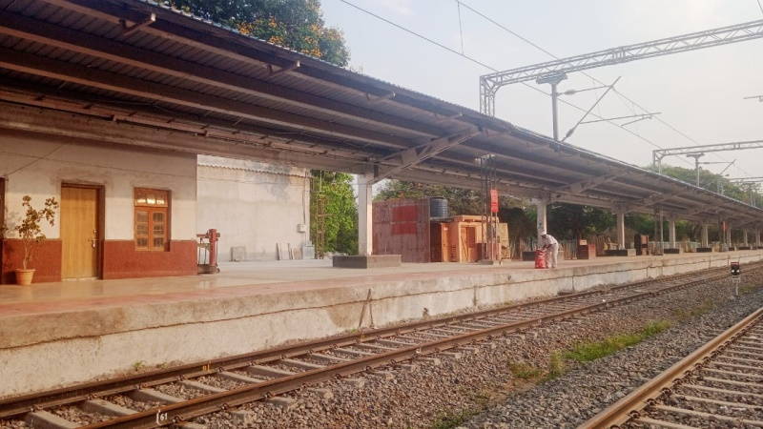  Date: 2.5.2025  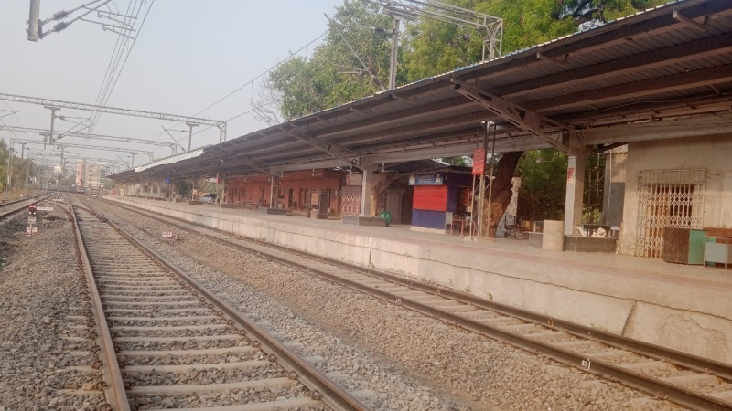
 | Lonand | Circulating area Sitting arrangement | Date: 27.4.2025  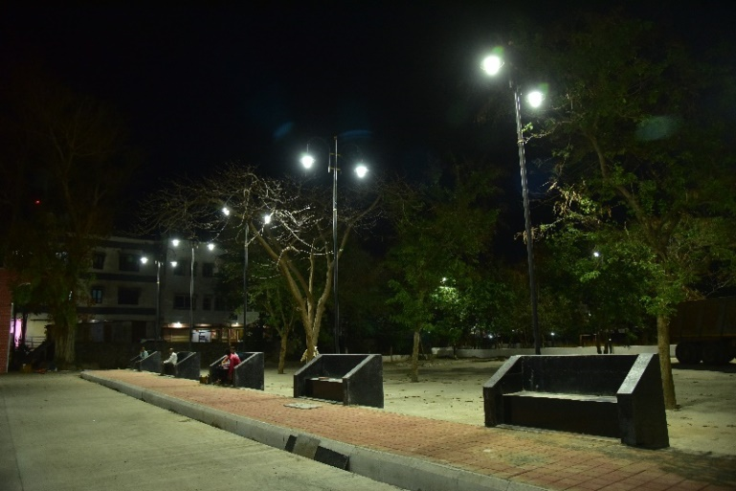
 | Lonand | COP | Date: 27.4.2025  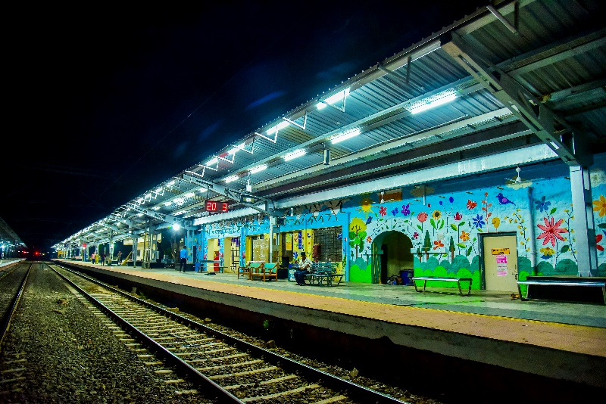
 | Lonand | Portico Interior | Date: 27.4.2025  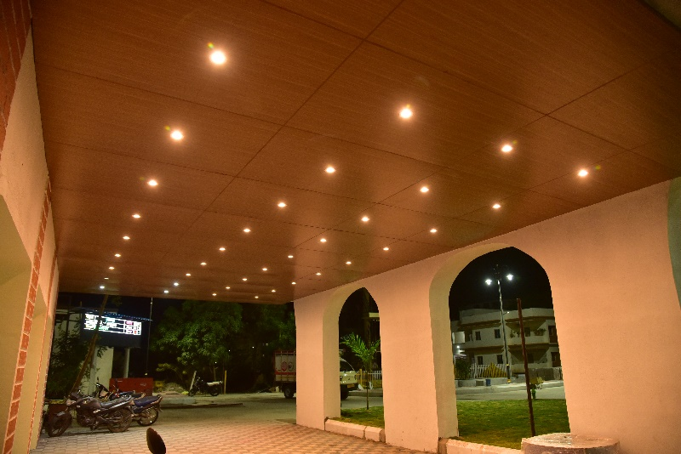
 | Kedgaon | Toilet | Date: 27.4.2025  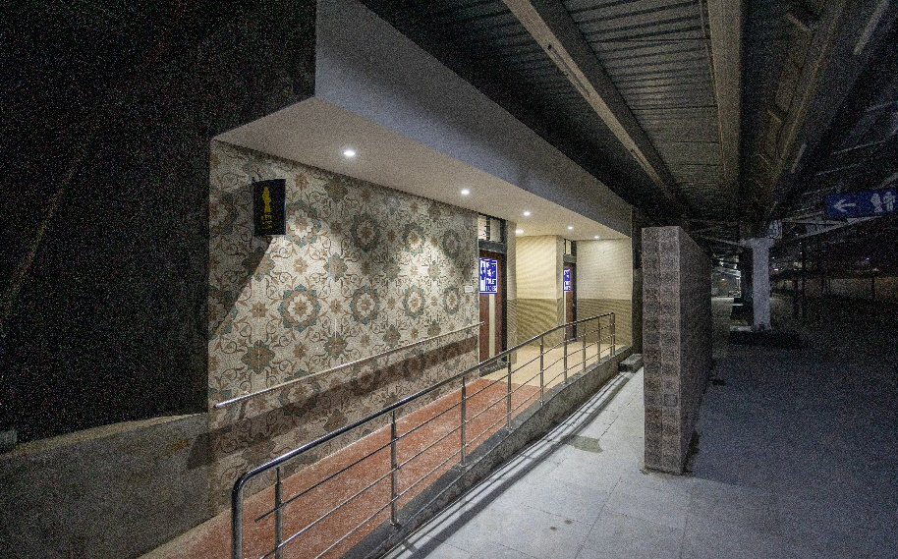
 | Kedgaon |  | Date: 27.4.2025  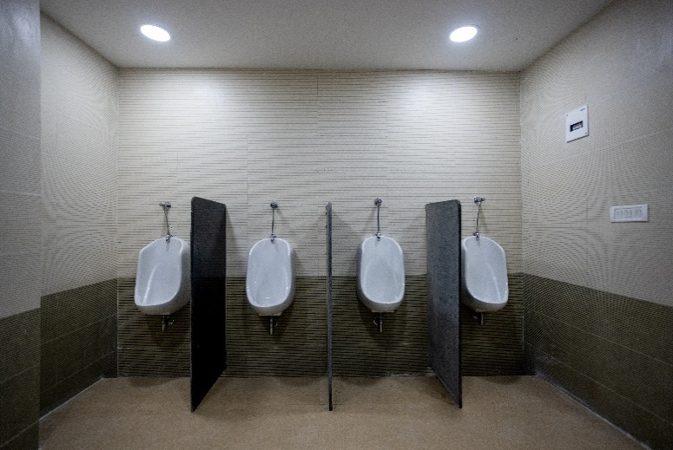  Date: 27.4.2025  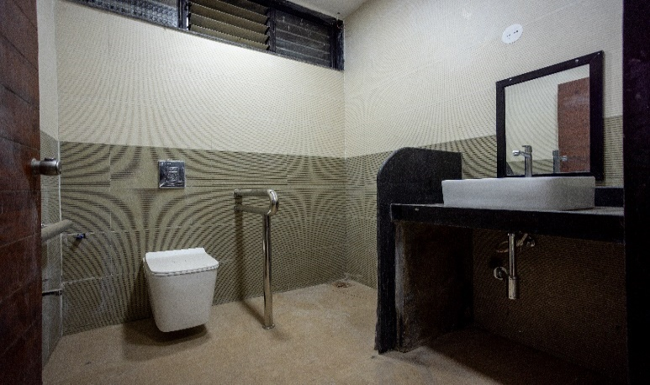  Date: 27.4.2025  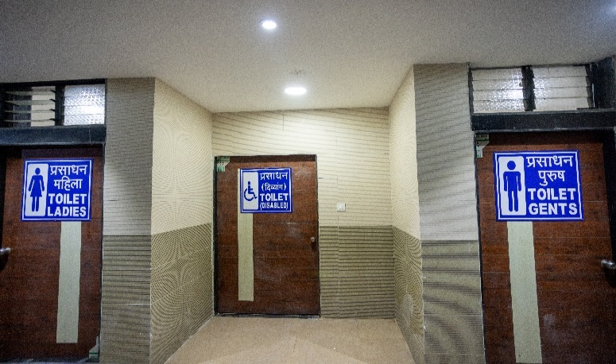  Date: 27.4.2025  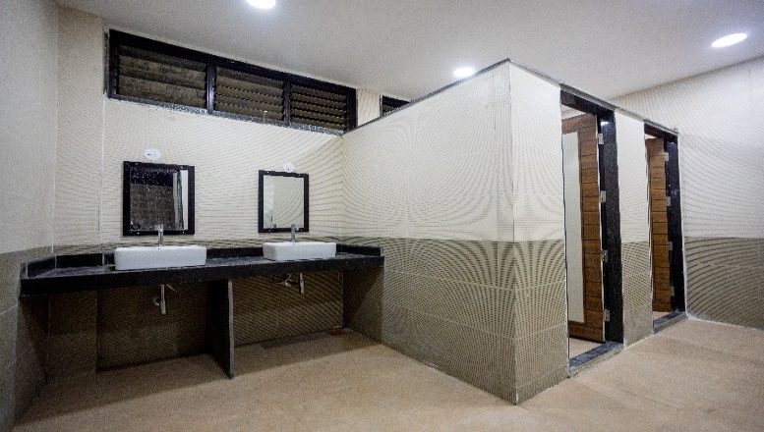
- Detailed formats of PCDO for Customer Amenities are enclosed herewith.

CPM/GSU/ PA

